DSA0610-DATA HANDLING AND VISUALISATION FOR DATA SPHERE
Day-1 V.Sree Ruthin Reddy
192324112
1.Visualize Scatter plot for given dataset.
Aim: To visualize the relationship between Weight and Height using a scatter plot in R with ggplot2, in order to observe trends or correlations between the two variables.
Algorithm:
- Import the ggplot2 library.
- Create a data frame containing Weight and Height values.
- Initialize the ggplot object by mapping Weight to the x-axis and Height to the y-axis.
- Add scatter points using geom_point() with specified color and size.
- Add title and axis labels using labs().
- Apply a minimal theme using theme_minimal().
Program:
library(ggplot2)
weight_height_data <- data.frame(
Weight = c(60, 65, 70, 72, 75),
Height = c(170, 175, 168, 180, 178)
)
ggplot(weight_height_data, aes(x = Weight, y = Height)) +
geom_point(color = "blue", size = 3) +
labs(title = "Weight vs. Height",
x = "Weight (kg)",
y = "Height (cm)")+
theme_minimal()

Output:
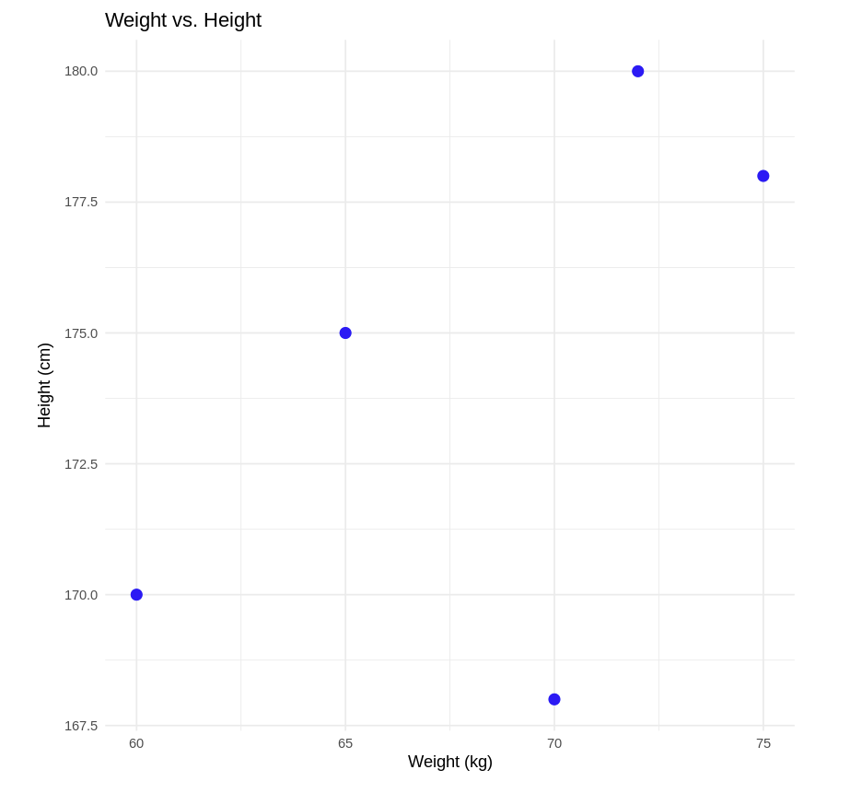
2. Visualize a Line Plot for the Given Population Data
Aim: To visualize the trend of population growth over years using a line plot in R with ggplot2.
Algorithm:
- Import the ggplot2 library.
- Create a data frame containing Year and Population values.
- Initialize the ggplot object by mapping Year to the x-axis and Population to the y-axis.
- Draw a line plot using geom_line() to show the trend.
- Add points using geom_point() to highlight individual data values.
- Add title and axis labels using labs().
- Apply a minimal theme using theme_minimal().
Program:
library(ggplot2)
year_population_data <- data.frame(
Year = 2010:2014,
Population = c(1000, 1020, 1040, 1060, 1080)
)
ggplot(year_population_data, aes(x = Year, y = Population)) +
geom_line(color = "green", linewidth = 1) +
geom_point(color = "red", size = 3) +
labs(
title = "Year vs Population",
x = "Year",
y = "Population"
) +
theme_minimal()
Output:
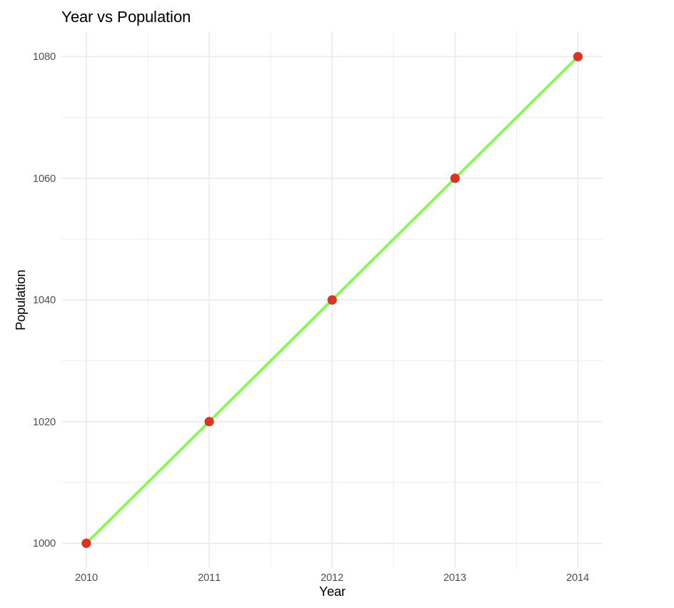
3. Bar Plot
Aim: To visualize and compare the sales of different products using a bar chart in R with ggplot2.
Algorithm:
- Import the ggplot2 library.
- Create a data frame containing Product names and their Sales values.
- Initialize the ggplot object by mapping Product to the x-axis and Sales to the y-axis.
- Use geom_bar() with stat = "identity" to plot actual sales values.
- Add title and axis labels using labs().
- Apply a minimal theme using theme_minimal().
Program:
library(ggplot2)
sales_data <- data.frame(
Product = c("A", "B", "C", "D", "E"),
Sales = c(300, 450, 500, 350, 400)
)
ggplot(sales_data, aes(x = Product, y = Sales, fill = Product)) +
geom_bar(stat = "identity") +
labs(
title = "Sales by Product",
x = "Product",
y = "Sales"
) +
theme_minimal()
Output:
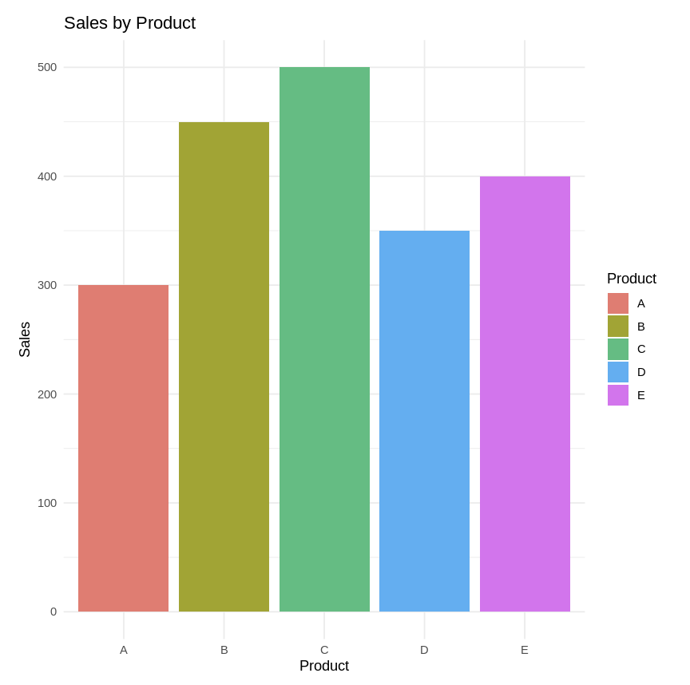
4.Histogram
Aim: To visualize the distribution of ages using a histogram in R with ggplot2.
Algorithm:
- Import the ggplot2 library.
- Create a data frame containing age values.
- Initialize the ggplot object by mapping Age to the x-axis.
- Use geom_histogram() to divide the data into bins of width 5.
- Customize the histogram using fill color, border color, and transparency.
- Add title and axis labels using labs().
- Apply a minimal theme using theme_minimal().
Program:
library(ggplot2)
age_data <- data.frame(
Age = c(22, 25, 25, 28, 30, 32, 35, 35, 35,
40, 42, 45, 45, 48, 50, 52, 55, 55, 60, 65)
)
ggplot(age_data, aes(x = Age)) +
geom_histogram(
binwidth = 5,
fill = "purple",
color = "black",
alpha = 0.7
) +
labs(
title = "Age Distribution",
x = "Age",
y = "Frequency"
) +
theme_minimal()

Output:
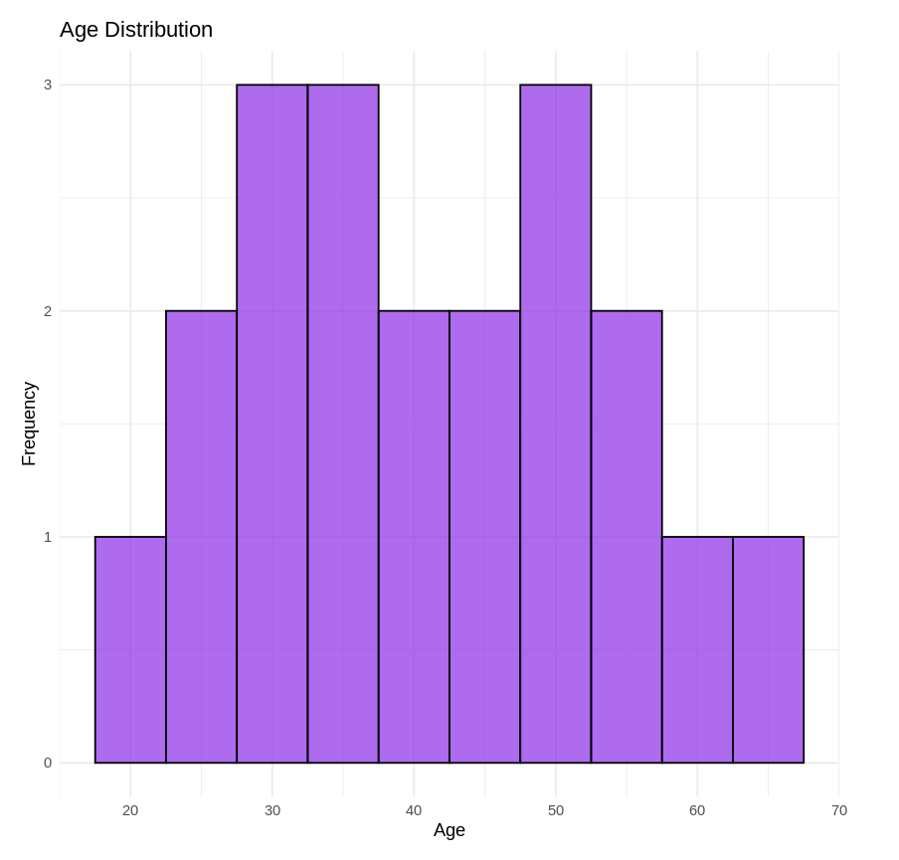
5.Pie Chart
Aim: To visualize the market share distribution of companies using a pie chart in R with ggplot2.
Algorithm:
- Import the ggplot2 library.
- Create a data frame containing company names and their market share values.
- Initialize the ggplot object with a constant x value and market share mapped to y-axis.
- Use geom_bar() with stat = "identity" to represent actual values.
- Convert the bar chart into a pie chart using coord_polar().
- Add title and remove axis labels using labs().
- Apply theme_void() and adjust legend position.
Program:
library(ggplot2)
market_share_data <- data.frame(
Company = c("A", "B", "C", "D"),
Market_Share = c(20, 30, 25, 25)
)
ggplot(market_share_data, aes(x = "", y = Market_Share, fill = Company)) +
geom_bar(stat = "identity", width = 1) +
coord_polar(theta = "y") +
labs(
title = "Market Share by Company",
x = NULL,
y = NULL
) +
theme_void() +
theme(legend.position = "right")

Output:
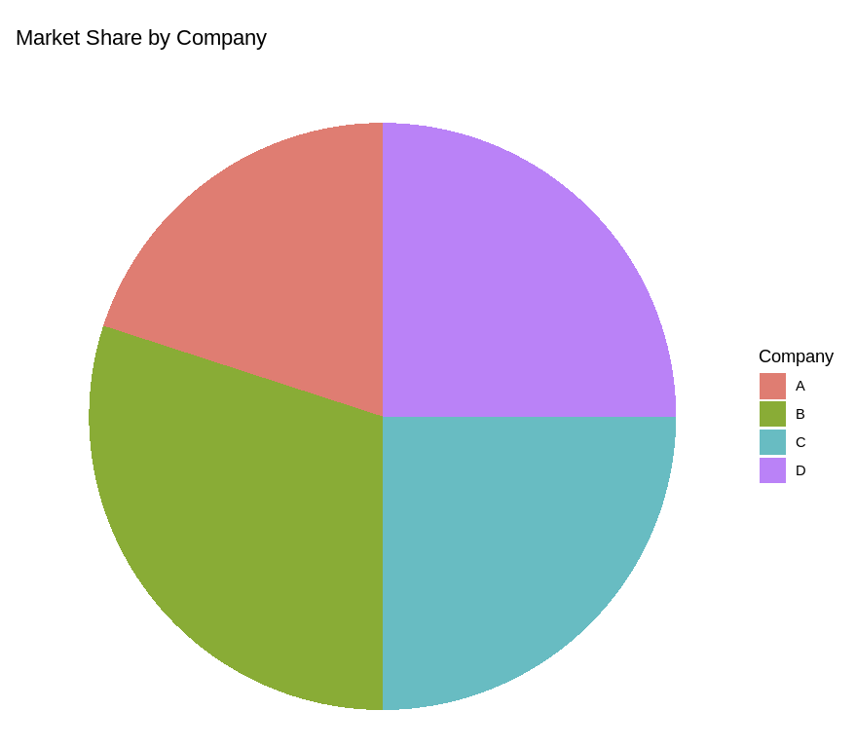
6.Box Plot
Aim: To compare the distribution of exam scores between Class A and Class B using a box plot in R with ggplot2.
Algorithm:
- Import the ggplot2 library.
- Create a data frame containing Class labels and corresponding Scores.
- Initialize the ggplot object by mapping Class to the x-axis and Scores to the y-axis.
- Use geom_boxplot() to visualize the score distribution for each class.
- Add title and axis labels using labs().
- Apply a minimal theme using theme_minimal().
Program:
library(ggplot2)
scores_data <- data.frame(
Class = c("A", "A", "A", "A", "B", "B", "B", "B"),
Scores = c(85, 90, 78, 92, 88, 76, 80, 84)
)
ggplot(scores_data, aes(x = Class, y = Scores, fill = Class)) +
geom_boxplot() +
labs(
title = "Exam Scores by Class",
x = "Class",
y = "Scores"
) +
theme_minimal()
Output:
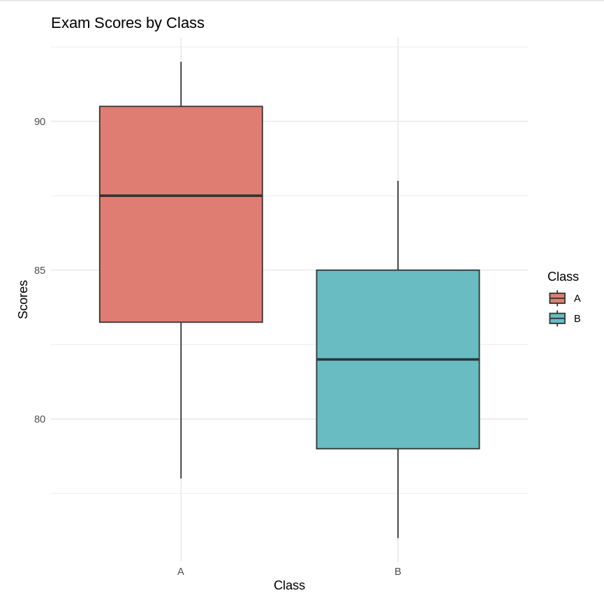
6.Density Plot
Aim: To visualize the distribution pattern of weight values using a density plot in R with ggplot2.
Algorithm:
- Import the ggplot2 library.
- Create a data frame containing weight values.
- Initialize the ggplot object by mapping Weight to the x-axis.
- Use geom_density() to estimate the probability density of the data.
- Customize the plot using fill color and transparency.
- Add title and axis labels using labs().
- Apply a minimal theme using theme_minimal().
Program:
library(ggplot2)
weights_data <- data.frame(
Weight = c(60, 65, 70, 75, 80, 85, 90, 95, 100)
)
ggplot(weights_data, aes(x = Weight)) +
geom_density(fill = "lightblue", alpha = 0.7) +
labs(
title = "Density Plot of Weights",
x = "Weight (kg)",
y = "Density"
) +
theme_minimal()
Output:
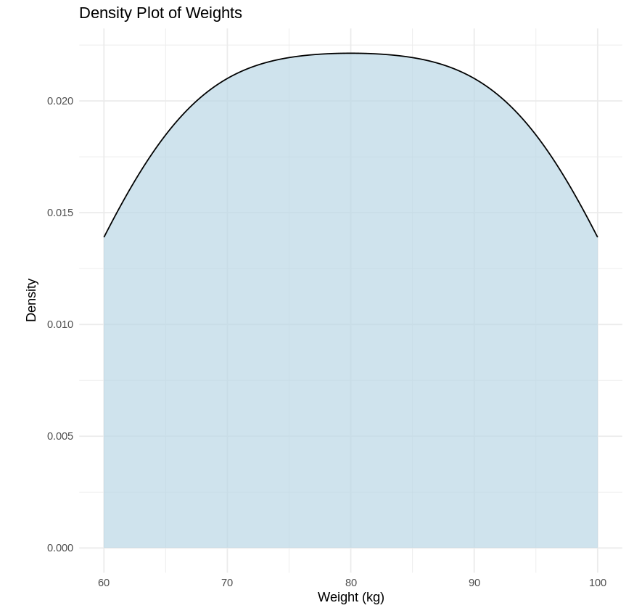
8.Voilin Plot
Aim: To compare the distribution and density of scores between Group X and Group Y using a violin plot in R with ggplot2.
Algorithm:
- Import the ggplot2 library.
- Create a data frame containing Group labels and corresponding Score values.
- Initialize the ggplot object by mapping Group to the x-axis and Score to the y-axis.
- Use geom_violin() to display the density distribution for each group.
- Add title and axis labels using labs().
- Apply a minimal theme using theme_minimal().
Program:
library(ggplot2)
scores_group_data <- data.frame(
Group = c("X", "X", "X", "X", "Y", "Y", "Y", "Y"),
Score = c(80, 85, 78, 92, 88, 76, 80, 84)
)
ggplot(scores_group_data, aes(x = Group, y = Score, fill = Group)) +
geom_violin(trim = FALSE) +
labs(
title = "Scores by Group",
x = "Group",
y = "Score"
) +
theme_minimal()

Output:
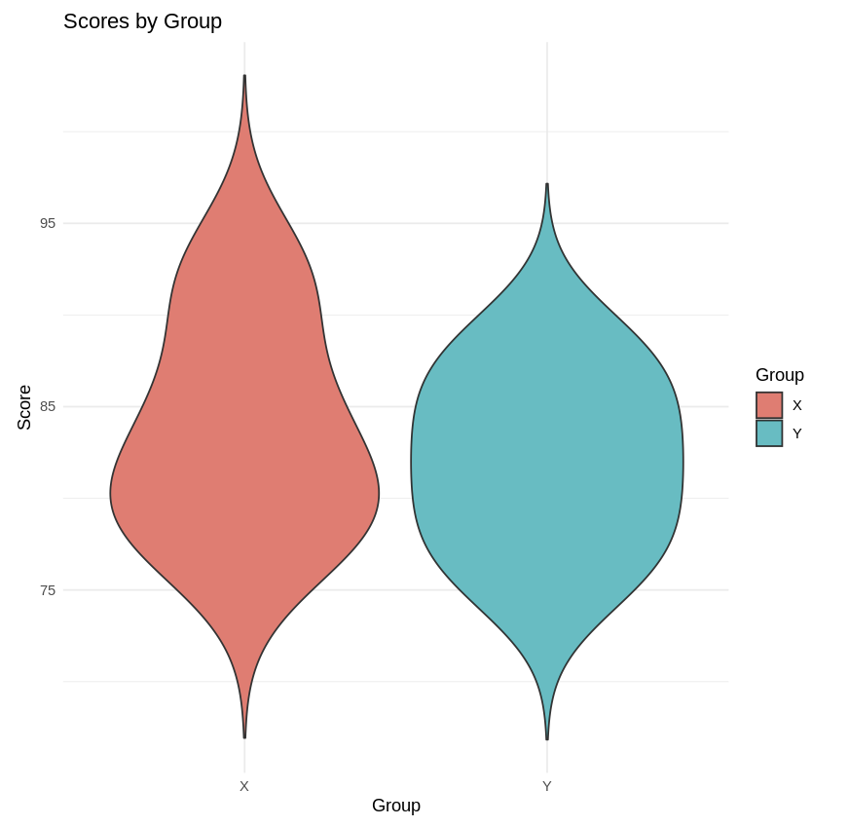

9.Heat Map
Aim: To visualize and compare monthly temperature variations across different cities using a heatmap in R with ggplot2.
Algorithm:
- Import required libraries (ggplot2 and reshape2).
- Create a data frame containing monthly temperature values for each city.
- Convert the data from wide format to long format using melt().
- Initialize the ggplot object by mapping Month to x-axis, City to y-axis, and temperature to fill color.
- Use geom_tile() to create the heatmap.
- Apply a color gradient to represent temperature intensity.
- Add title and axis labels, and apply a minimal theme.
Program:
library(ggplot2)
install.packages("reshape2") # Install the reshape2 package
library(reshape2)
temperature_data <- data.frame(
Month = c("Jan", "Feb", "Mar", "Apr", "May"),
City_A = c(5, 6, 7, 8, 9),
City_B = c(10, 11, 12, 13, 14),
City_C = c(15, 16, 17, 18, 19)
)
melted_data <- melt(temperature_data, id.vars = "Month")
ggplot(melted_data, aes(x = Month, y = variable, fill = value)) +
geom_tile(color = "grey80") +
scale_fill_gradient(low = "white", high = "red") +
labs(
title = "Monthly Temperatures",
x = "Month",
y = "City"
) +
theme_minimal()
Output:
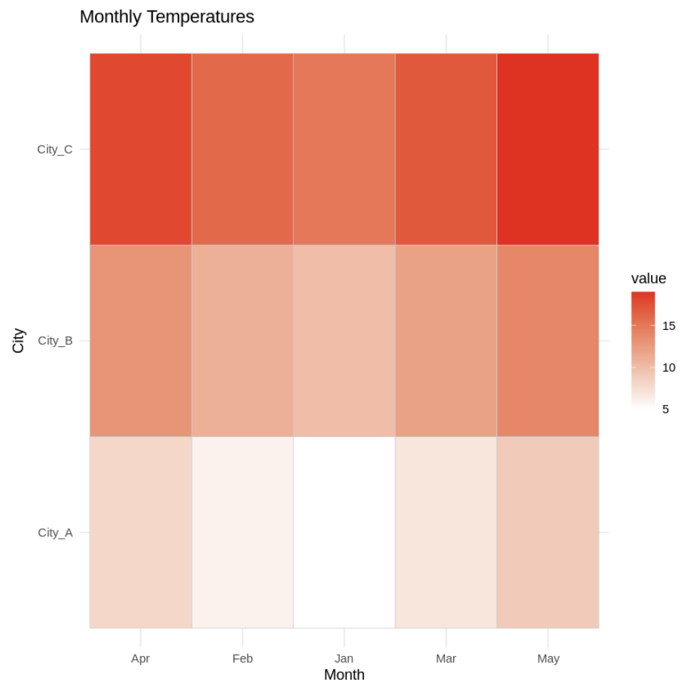
10.Facet Plot
Aim: To visualize and compare monthly sales performance across different regions using a facet plot in R with ggplot2.
Algorithm:
- Import the ggplot2 library.
- Create a data frame containing Month, Region, and Sales values.
- Initialize the ggplot object by mapping Month to the x-axis, Sales to the y-axis, and Region to fill color.
- Use geom_bar() with stat = "identity" to plot actual sales values.
- Apply facet_wrap() to create separate subplots for each region.
- Add title and axis labels using labs().
- Apply a minimal theme using theme_minimal().
Program:
library(ggplot2)
sales_region_data <- data.frame(
Month = c("Jan", "Jan", "Feb", "Feb", "Mar", "Mar"),
Region = c("East", "West", "East", "West", "East", "West"),
Sales = c(200, 150, 220, 170, 210, 160)
)
ggplot(sales_region_data, aes(x = Month, y = Sales, fill = Region)) +
geom_bar(stat = "identity", position = "dodge") +
facet_wrap(~ Region) +
labs(
title = "Sales by Month and Region",
x = "Month",
y = "Sales"
) +
theme_minimal()

Output:
